Biomedicine & Pharmacotherapy
Volume 109, January 2019, Pages 1860-1866
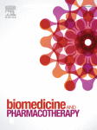

α, β-Amyrin, a pentacyclic triterpenoid from Protium heptaphyllum suppresses adipocyte differentiation accompanied by down regulation of PPARγ and C/EBPα in 3T3-L1 cells
Author links open overlay panelKarina Mourade MeloªFrancisca Tuelly Bandeirade Oliveira^{b}Rose AnnyCosta Silva^{b}Ana LuizaGomes Quinderé^{b}José Delano BarretoMarinho Filho^{c}Ana JérsiaAraújo^{c}Eanes DelgadoBarros Pereira^{b}Adonias AlmeidaCarvalho^{d}Mariana HelenaChaves^{d}Vietla SatyanarayanaRao^{e}Flávia AlmeidaSantos^{e}
Show more
Share
Cite
https://doi.org/10.1016/j.biopha.2018.11.027Get rights and content
Under a Creative Commons license
Open access

Highlights
•
The triterpenoid, α, β-Amyrin manifests anti-adipogenicity in 3T3-L1 cells.
•
α, β-Amyrin inhibits preadipocyte differentiation.
•
α,β-Amyrin suppresses adipogenic transcription factors, PPARγ and C/EBPα.
•
α,β-Amyrin stimulates the glucose transporter GLUT4 and promotes AMPK phosphorylation.

Abstract
Previous studies have reported the anti-obesity effects of α, β-Amyrin in high fat-fed mice. This study aimed to evaluate whether α, β-Amyrin has an anti-adipogenic effect in 3T3-L1 murine adipocytes and to explore the possible underlying mechanisms. 3T3-L1 pre-adipocytes were differentiated in a medium containing insulin, dexamethasone, and 1-methyl-3-isobutylxanthine. Cytotoxicity of α, β-Amyrin was assessed by MTT assay. Lipid content in adipocytes was determined by Oil-Red O staining. In addition, the protein expression levels of peroxisome proliferator-activated receptor gamma (PPARγ), CCAAT/enhancer binding proteins alpha (C/EBPα), beta (C/EBPβ), and delta (C/EBPδ) and glucose transporter 4 (GLUT4) were determined by qRT-PCR and western blot analysis. Oil-Red O staining revealed markedly reduced fat accumulation by α, β-Amyrin (6.25–50 μg/mL) without affecting cell viability. Furthermore, our results indicate that α, β-Amyrin can significantly suppress the adipocyte differentiation by downregulating the expression levels of adipogenesis-related key transcription factors such as PPARγ and C/EBPα, but not C/EBPβ or C/EPBδ. In addition, the protein expression of membrane GLUT4 in 3T3- L1 adipocytes treated with α, β-Amyrin was significantly higher than in control cells, indicating that α, β-Amyrin augments glucose uptake. These findings suggest that α, β-Amyrin exerts an anti-adipogenic effect principally via modulation of lipid and carbohydrate metabolism in 3T3-L1cells. The present in vitro findings, taken together with our earlier observation of the anti-obesity effect in vivo, suggest that α, β-Amyrin can be developed as a new therapeutic agent for treatment and prevention of obesity.

Graphical abstract
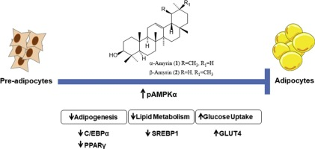
- Download : Download high-res image (105KB)
- Download : Download full-size image
- Previous article in issue
- Next article in issue

Keywords
α, β-Amyrin
3T3-L1 cells
Adipocyte differentiation
PPARγ
C/EBPα
GLUT4
Anti-adipogenecity

1. Introduction
Obesity is a multifactorial disease and its incidence has increased at an alarming rate in recent years, thus becoming a worldwide health problem, with incalculable social costs [1]. The availability of only few effective treatment options for most individuals with obesity has prompted the search for natural products. In this regard, the potential of herbal compounds to counteract obesity are currently receiving much attention [[2], [3], [4]]. α, β-Amyrin is an isomeric triterpenoidmixture isolated from Protium heptaphyllum (Aubl.) March (Burceracea Family), comprising two different subgroups of pentacyclic triterpenoids, ursane and oleanane (60:40), respectively [5]. The only structural variation involves the E-ring methyl group, which occupies the position either at C-19 (α-Amyrin) or C-20 (β-Amyrin) (Fig. 1). α, β-Amyrin has been shown to possess a wide spectrum of biological and pharmacological activities including anti-inflammatory [6,7], anti-nociceptive [8], gastroprotective [9], hepatoprotective [10], anti-hyperglycemic and hypolipidemic [11] effects. More recently, we reported the anti-obesity effects of α, β-Amyrin in high fat-fed mice, mediated by regulation of various pathways, including lipid absorption, energy intake and expenditure, increasing lipolysis, and decreasing lipogenesis [12]. Given that multiple pathways influence energy balance, it is likely that therapies targeting more than one control system may be required to meet the needs of obese patients wanting to lose weight.
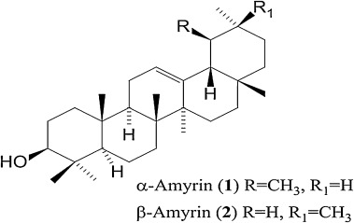
- Download : Download high-res image (114KB)
- Download : Download full-size image
Fig. 1. The chemical structure of α, β-Amyrin.
Adipocytes influence metabolism and energy intake and thus serves as an important target for the development of anti-obesity and anti-diabetic therapies [13]. It has been suggested that irregular accumulation of triglycerides in adipocytes may be a cause of metabolic disorders and obesity. The mouse 3T3-L1 pre-adipocyte cell line is an important cell model for studying adipogenesis in vitro. Both ursolic and oleanolic acids structurally related to α, β-Amyrin have been shown to inhibit 3T3-L1 pre-adipocyte differentiation and adipogenesis [14,15]. The increase in prevalence of type 2 diabetes is closely linked to the upsurge in obesity [16], a clinical feature consistent with our earlier experimental findings showing that obesity development in HFD fed mice is associated with hyperglycemia and insulin resistance, both of which can ameliorated by pretreatment with α, β-Amyrin [12]. In order to support our in vivo findings on the anti-adipogenic potential of α, β-Amyrin, the present study investigated its ability to inhibit adipogenesis in vitro, using 3T3-L1 cells.

2. Materials and methods

2.1. Drugs and chemicals
Dulbecco’s modified Eagle’s medium (DMEM), penicillin-streptomycin, newborn calf serum (NCS) and fetal bovine serum (FBS) were purchased from Gibco by Life Technologies (Waltham, MA, USA). 3-isobutyl-1-methylxanthine (IBMX), dexamethasone, insulin, sodium orthovanadate, phenylmethylsulfonyl fluoride, protease inhibitor cocktail and RIPA lysis buffer were purchased from Sigma Aldrich (St. Louis, MO, USA). Antibodies to PPARγ, C/EBPα, C/EBPβ and C/EBPδ were obtained from Abcam (Cambridge, UK). Antibodies to β-actin, GLUT4, AMPKα, pAMPKα, SREBP1, and anti-rabbit IgG were obtained from Cell SignalingTechnology (Danvers, MA, USA).

2.2. Extraction and isolation of α,β-Amyrin
The resinous exudate from the trunk wood of P. heptaphyllum was collected from the municipal area of Timon, Maranhão, Brazil, after its identification by a botanist (Roseli Farias de Melo Barros). A voucher sample (no. TEPB 18247) was deposited at the Graziela Barroso Herbarium of Federal University of Piauı́. The crude resin (410 g) was dissolved in methanol/dichloromethane (4:1), filtered, and the solvent was evaporated in a rotary evaporator to obtain 408 g (99.5%) of amorphous white resin. Phytochemical analysis of the resin revealed the presence of pentacyclic triterpenoids (56%), which were identified by ¹H and ¹³C NMR and mass spectroscopy. These were the mixture of α- and β-Amyrin (45.25%), brein and maniladol (9.5%) and a small quantity (1.25%) of a mixture of lupeone, α- and β-amyrinone [5]. The extraction and isolation of α- and β-Amyrin from the crude resin was carried out as described earlier [5] and its structural identity was confirmed by ¹H and ¹³C NMR spectral analysis, based on the method developed by Gallegos and Roque [17] and in comparison with literature data [18]. The ratio of α- and β-Amyrin in this mixture was 63:37, calculated by ¹H NMR, by dividing the signal area of olefinic hydrogens δ = 5.14 (α-Amyrin) and δ = 5.20 (β-Amyrin) by signal area of δ = 3.24 (dd, J = 11.0 and 5.0 Hz), attributed to H-3 in the two triterpenes and multiplied by 100. The determined optical rotation for the mixture was +92.5 (c 0.5 in CHCl₃).
α-Amyrin (1): ¹H NMR (500 MHz, CDCl₃): 3.24 (dd, J = 11.0 and 5.0 Hz, H-3), 5.14 (t, J = 3.6 Hz, H-12). δ ¹³C NMR (125 MHz, CDCl₃): 39.2 (C-1), 27.6 (C-2), 79.4 (C-3), 37.4 (C-4), 55.6 (C-5), 18.8 (C-6), 33.4 (C-7), 40.2 (C-8), 48.0 (C-9), 34.2 (C-10), 23.8 (C-11), 124.8 (C-12), 140.0 (C-13), 42.1 (14), 28.5 (C-15), 27.0 (C-16), 31.5 (C-17), 59.5 (C-18), 40.1 (C-19), 40.0 (C-20), 33.1 (C-21), 41.9 (C-22), 28.8 (C-23), 16.1 (C-24), 16.0 (C-25), 17.9 (C-26), 24.1 (C-27), 29.2 (C-28), 17.3 (C-29), 21.8 (C-30).
β-Amyrin (2): ¹H NMR (500 MHz, CDCl₃): 3.24 (dd, J = 11.0 and 5.0 Hz, H-3), 5.20 (t, J = 3.6 Hz, H-12). δ ¹³C NMR (125 MHz, CDCl₃): 39.0 (C-1), 27.4 (C-2), 79.4 (C-3), 39.2 (C-4), 55.6 (C-5), 18.8 (C-6), 31.7 (C-7), 40.4 (C-8), 48.1 (C-9), 37.3 (C-10), 23.9 (C-11), 122.1 (C-12), 145.6 (C-13), 42.5 (C-14), 27.7 (C-15), 26.6 (C-16), 32.9 (C-17), 47.6 (C-18), 47.2 (C-19), 31.5 (C-20), 35.1 (C-21), 37.6 (C-22), 28.8 (C-23), 16.0 (C-24), 15.9 (C-25), 17.2 (C-26), 26.4 (C-27), 28.6 (C-28), 33.8 (C-29), 23.7 (C-30).

2.3. Cell culture and adipocyte differentiation
3T3-L1 preadipocytes (ATCC® CL-173™) were maintained in Dulbecco’s Modified Eagle’s Medium (DMEM) supplemented with 10% newborn calf serum, 100 U/mL penicillin and 0.1 μg/mL streptomycin at 37 °C in a humidified atmosphere of 5% CO₂. Cells were seeded at a density of 1 × 10⁵cells/well. At this density, cells reached confluence after 2 days. Then the differentiation was initiated (designated "day 0") in DMEM containing 10% fetal bovine serum (FBS), 0.5 mM 3-isobytyl-1-methylxanthine, 0.25 μM dexamethasone, 1 μg/mL insulin and 100 U/mL penicillin and 0.1 μg/mL streptomycin. Every 48 h afterwards, the medium was replaced with supplemented DMEM plus 1 μg/mL insulin until day 10 after differentiation induction [19]. α, β-Amyrin was dissolved in DMSO (0.1% v/v) and added to the medium for a final concentration of 6.25–50 μg/mL from day 0–10. Vehicle group cells were treated with the same volume of 0.1% DMSO.

2.4. Cytotoxicity assay
The effect of α, β-Amyrin on viability of differentiated 3T3-L1 cells was assessed by the MTT assay [20]. Differentiated 3T3-L1 adipocytes were obtained as previously described. α, β-Amyrin was dissolved in DMSO (0.1% v/v) and added to the medium for a final concentration of 6.25–400 μg/mL from day 0-10. MTT reagent was added and cell viability was calculated as the percentage of viable cells in the α, β-Amyrin-treated group versus untreated controls [15].

2.5. Oil Red O staining
Intracellular lipid accumulation was measured using Oil Red O. 3T3-L1 cells were washed with phosphate-buffered saline (PBS) before being fixed for 1 h with 4% formaldehyde in PBS. The cells were stained with Oil Red O solution (60% isopropanol and 40% water) for 2 h and then exhaustively rinsed with distillated water. The reddish dye retained by cells was removed with 60% isopropanol and the absorbance was measured using a microplate reader at 510 nm (Biochrom® Asys UVM340, Cambourne, Cambridge, UK) [21].

2.6. GLUT4 expression and translocation in 3T3-L1 adipocytes
3T3-L1 preadipocytes were cultured and induced to differentiate for 8 days (according to the previously described method) and further incubated in starved medium (high glucose DMEM with 0.3% BSA) overnight [22]. Then different concentrations of α, β-Amyrin were added for 24 h at 37 °C in the presence of 1 μg/mL insulin in starved medium [15]. For measurement of total GLUT4, total proteins were used, while for the translocation of GLUT4, membrane proteins were separated using the protocol suggested by Campello et al. [23]. To prepare the plasma membrane fractions, the cells were washed with cold PBS, scraped off the plates into homogenization buffer (Tris-HCl 10 mM; EDTA 1 mM; sucrose 250 mM, pH 7.4) and centrifuged at 1000 × g/10 min/4 °C. The supernatant was ultracentrifuged at 150,000 × g, 75 min, 4 °C. The pellet obtained, containing the total plasma membrane protein, was suspended with homogenization buffer and kept at −20 °C. The protein of GLUT4 was determined using western blotting, with β-actin being used as the loading control.

2.7. Quantitative real-time polymerase chain reaction (qRT-PCR)
Total RNA was isolated from 3T3-L1 adipocytes with a PureLink™ RNA Mini kit (Invitrogen, Carlsbad, CA, USA). One microgram of RNA was reverse transcribed by the High Capacity cDNA Reverse Transcription kit (Applied Biosystems, Foster City, CA, USA) to obtain cDNA according to the protocols provided by the manufacturer. Briefly, the total reaction volume was 20 μL with the reaction incubated as follows: 10 min at 25 °C, 120 min at 37 °C, 5 min at 85 °C, and holding at 4 °C. Real-time PCR was performed with an Mx3005p PCR system (Agilent Genomics, Santa Clara, CA, USA) using master mix GoTaq kit with SYBER green (Promega, Madison, WI, USA) according to the protocol provided by the manufacturer. Briefly, PCR was performed in a final volume of 30 μL. PCR reactions consisted of an initial denaturating cycle at 95 °C for 10 min, followed by 40 amplification cycles: 15 s at 95 °C and 1 min at 59 °C. The primers used are shown in Table 1. Briefly, cDNA (200 ng/μL) from the RT reaction was added of the GoTaq q-PCR Master Mix (Promega, Madison, WI, USA) and primers. The samples were incubated at 95 °C for 2 min, followed by 40 cycles at 95 °C for 15 s and at 59 °C for 1 min. Relative mRNA levels of targeting genes were normalized to the β-actin gene by employing the comparative threshold cycle (2^{−△△CT}) method. The analysis was carried out in triplicate.
Table 1. Primers.
Gene | Empty Cell | Primary sequence
PPARγ2 | Forward | 5’GGGATAAAGCATCAGGCTTCC3’
 | Reverse | 5’CAGCAAGGCACTTCTGAAACC3’
C/EBPα | Forward | 5’GAAGGTGCTGGAGTTGACCAG3’
 | Reverse | 5’CCTTGACCAAGGAGCTCTCAG3’
C/EBPβ | Forward | 5’GGACAA GCTGAGCGACGAGTA3’
 | Reverse | 5’CAGCTGCTCCACCTTCTTCTG3’
C/EBPδ | Forward | 5’ACTCCTGCCATGTACGACGAC3’
 | Reverse | 5’GAAGAGGTCGGCGAAGAGTTC3’
β-actin | Forward | 5’GGGA ATGGGTCAGAAGGACTC3’
 | Reverse | 5’GGTGTGGTGCCAGATCTTCTC3’

2.8. Western blot analysis
Undifferentiated or differentiated 3T3-L1 cells were washed with PBS and lysed with RIPA lysis buffer (50 mM Tris-HCl, pH 8, 150 mM NaCl, 0.5% sodium deoxycholate, 1% Igepal CA-630 (NP-40), 0.1% sodium dodecyl sulfate) supplemented with sodium orthovanadate (200 mM), phenylmethylsulfonyl fluoride (200 mM) and protease inhibitor cocktail. 20 μg of total protein was separated on 12% or 8% SDS-PAGE gel and transferred onto a PVDF membrane (Bio-Rad Laboratories, Hercules, CA, USA). Incubation with primary antibodies PPARγ (1:1000), C/EBPα (1:500), C/EBPβ (1:1000), C/EBPδ (1:1000), GLUT4 (1:1000), AMPKα (1:1000), pAMPKα (1:1000), SREBP1 (1:1000) and β-actin (1:1000) was at 4℃ for 1 h, and incubation with horse radish peroxidase-conjugated secondary antibodies for chemiluminescent detection (1:3000) was at room temperature for 1 h. Amersham ECL™ Prime Western Blotting detection reagent (Bio-Rad Laboratories, Hercules, CA, USA) was used. ChemiDoc™ MP Image System with Image Lab™ 5.1 software (Bio-Rad Laboratories, Hercules, California, USA) was used for acquisition and analysis of western blot images.

2.9. Statistical analysis
The results are expressed as mean ± standard deviation (SD). The statistical analyses were performed using the GraphPad Prism program (version 5.0). The treatment effect was determined using one-way ANOVA, followed by post-hoc Newman-Keuls multiple comparison test, where a P value less than 0.05 was considered significant.

3. Results

3.1. Cytotoxicity of α, β-Amyrin in 3T3-L1 cells
Treatment of differentiated 3T3-L1cells with various concentrations (6.25, 12.5, 25, 50, 100 and 200 μg/mL) of α, β-Amyrin did not affect adipocyte viability (Fig. 2). However, significant cytotoxicity was observed at 400 μg/mL concentration, with a decrease in cell viability of 43.2% (P < 0.001), compared to the control. Therefore, for further experiments we used a safe dosage range of 6.25–50 μg/mL.
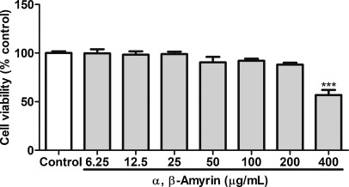
- Download : Download high-res image (128KB)
- Download : Download full-size image
Fig. 2. The effect of α, β-Amyrin on cell viability in 3T3-L1 cells. Values are expressed as mean ± SD. *** P < 0.001 vs. control (ANOVA, followed by Newman-Keuls test).

3.2. Suppressive effect of α, β-Amyrin on differentiation and lipid accumulation in 3T3-L1 cells
Light microscopy revealed that the 3T3-L1 cells were differentiated into mature adipocyte at day 10 following the addition of the differentiation induction medium (Fig. 3A). The effect of α, β-Amyrin on lipid accumulation was analyzed during the differentiation of 3T3-L1 cells using Oil Red O staining. As shown in Fig. 3A, the control group was differentiated into adipocytes and showed an increase in intracellular lipids. In contrast, α, β-Amyrin-treated cells showed a significantly reduced accumulation of intracellular lipids compared with the control group. The lesser intracellular lipid accumulation in the cells treated with α, β-Amyrin suggests that the treatment had a suppressive effect on the differentiation (Fig. 3A). The lipid content in 3T3-L1 cells treated with α, β-Amyrin (6.25, 12.5, 25, and 50 μg/mL) was significantly (P < 0.001) reduced by 34, 44, 68, and 75%, respectively, in comparison to the control cells (Fig. 3B).
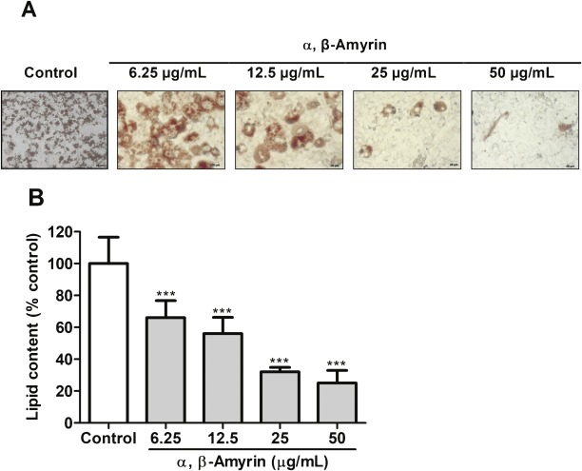
- Download : Download high-res image (480KB)
- Download : Download full-size image
Fig. 3. The effect of α, β-Amyrin treatment on the accumulation of lipids in 3T3-L1 cells. (A) Oil Red O staining of the treated cells and the controls at day 10 following the induction of differentiation and α, β-Amyrin treatment. (B) Quantification of lipid content in the treated cells. Values are expressed as mean ± SD. *** P < 0.001 vs. control (ANOVA, followed by Newman-Keuls test).

3.3. Effect of α, β-Amyrin on the expression of adipogenic genes and protein levels in 3T3-L1 adipocytes
To verify whether α, β-Amyrin inhibits the adipocyte differentiation, the effect of α, β-Amyrin was analyzed on the expression of the genes for PPARγ, C/EBPα, C/EBPβ and C/EBPγ using qRT-PCR and on the proteins levels of AMPK, SREBP1 and GLUT4 using western blot techniques. In comparison with undifferentiated cells, differentiated adipocytes showed significantly higher expression levels of PPARγ, C/EBPα, C/EBPβ and C/EBPδ (Fig. 4). While α, β-Amyrin reduced the expression of genes for the transcription factors PPARγ and C/EBPα, the expression levels of C/EBPβ and C/EBPδ were not altered significantly (Fig. 4). α, β-Amyrin (50 μg/mL) significantly enhanced the AMPK phosphorylation in differentiated adipocytes (Fig. 5). With respect to SREBP1, its expression was significantly reduced by α, β-Amyrin at a concentration of 50 μg/mL only (Fig. 6). Fig. 7 shows that the level of membrane GLUT4 expression in adipocytes treated with α, β-Amyrin (25 and 50 μg/mL) was higher than that in control adipocytes (P < 0.01), indicating that it could promote glucose uptake by transporting GLUT4 to the adipocyte.
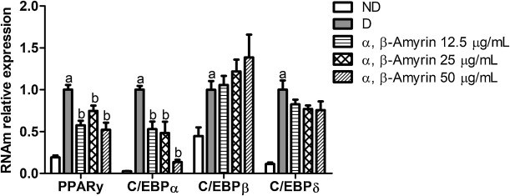
- Download : Download high-res image (277KB)
- Download : Download full-size image
Fig. 4. Effect of α, β-Amyrin treatment on the gene expression levels of PPARγ, C/EBPα, C/EBPβ and C/EBPδ in 3T3-L1 cells. Differentiated 3T3-L1 adipocytes were treated with α, β-Amyrin at concentrations of 12.5, 25 and 50 μg/mL. ND = non-differentiated; N = differentiated. Values are expressed as mean ± SD of 3 independent experiments realized in duplicate. ª P < 0.01 vs. ND; ^{b} P < 0.01 vs. D (ANOVA, followed by Newman-Keuls test).
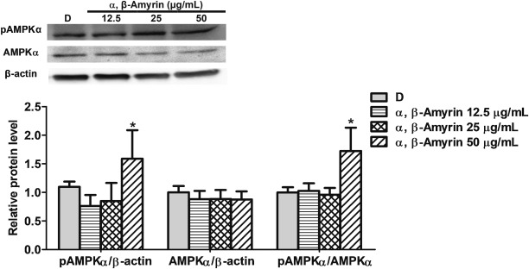
- Download : Download high-res image (361KB)
- Download : Download full-size image
Fig. 5. Effect of α, β-Amyrin treatment on phosphorylated and total AMPKα. Differentiated 3T3-L1 adipocytes were treated with α,β-Amyrin at concentrations of 12.5, 25 and 50 μg/mL. D = differentiated. p = phosphorylated. t = total. Values are expressed as mean ± SD of 3 independent experiments. * P < 0.01 vs. D (ANOVA, followed by Newman-Keuls test).
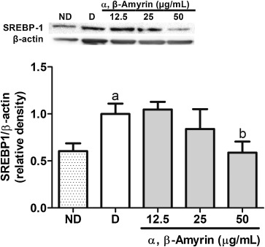
- Download : Download high-res image (193KB)
- Download : Download full-size image
Fig. 6. Effect of α, β-Amyrin treatment on the protein expression levels of SREBP1 in 3T3-L1 cells. Differentiated 3T3-L1 adipocytes were treated with α, β-Amyrin at concentrations of 12.5, 25 and 50 μg/mL and the protein content of mature SREBP1 (68 kDa) was analyzed. ND = non-differentiated; N = differentiated. Values are expressed as mean ± SD of 3 independent experiments. ª P < 0.01 vs. ND; ^{b} P < 0.01 vs. D (ANOVA, followed by Newman-Keuls test).
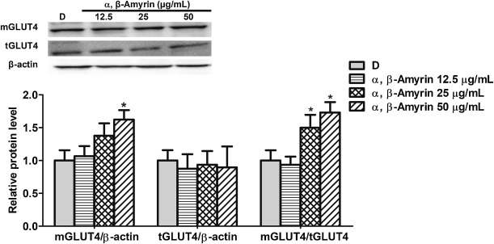
- Download : Download high-res image (403KB)
- Download : Download full-size image
Fig. 7. Effect of α, β-Amyrin treatment on protein expression level of membrane and total GLUT4 in 3T3-L1 cells. Differentiated 3T3-L1 adipocytes were treated with α, β-Amyrin at concentrations of 12.5, 25 and 50 μg/mL. D = differentiated. m = membrane. t = total. Values are expressed as mean ± SD of 3 independent experiments. * P < 0.05 vs. D (ANOVA, followed by Newman-Keuls test).

4. Discussion
Our previous studies have shown that α, β-Amyrin exerts anti-hyperglycemic, hypolipidemic, and anti-obesity effects in vivo [11,12]. In this investigation, we examined the effect of α, β-Amyrin on adipogenesis using 3T3-L1 cell cultures. Adipogenesis, the cellular differentiation of preadipocytes to adipocytes, is described as a cascade of gene expressions regulated by a small set of transcription factors. 3T3-L1 preadipocyte cell line is one of the best characterized and reliable in vitro models for studying cellular and molecular mechanisms of adipocyte differentiation [24]. Our results indicate that α, β-Amyrin can significantly reduce lipid accumulation and the expression levels of key adipogenic transcription factors, PPARγ and C/EBPα. Mouse PPARγ is a member of the nuclear receptor super family, which regulates the expression of many proteins involved in glucose homeostasis and plays a central role in adipocyte differentiation [25]. Furthermore, PPARγ and C/EBPα are known to play a pivotal role in modulating the differentiation of pre-adipocytes to adipocytes by their subsequent transactivationof adipocyte-specific genes [26,27]. CCAAT/enhancer binding protein α, β, δ (C/EBP α, β, δ) are essential transcriptional factors in regulating adipose development [28]. In this study, α, β-Amyrin down regulated the expression level of C/EBPα, but not of C/EBPβ or C/EPBδ, possibly due to the binding variation. Thus, inhibition of adipocyte differentiation by α, β-Amyrin is a key strategy to control obesity since an increase in adipose mass is caused by both adipocyte hypertrophy and adipocyte hyperplasia.
It is known that Oil Red O specifically stains triglycerides and cholesteryl oleate but no other lipids. This technique is a valuable tool for processing large numbers of cell cultures or samples in which adipose differentiation and/or accumulated triglycerides can be quantified. We used this technique and Oil Red O staining evidenced that α, β-Amyrin significantly inhibits pre-adipocyte differentiation and accumulation of intracellular lipids in a manner similar to ursolic and oleanolic acids, which have structural similarity to α,β-Amyrin [14,15]. These effects of α,β-Amyrin were accompanied by a remarkable reduction in mRNA levels for the adipogenic master regulators (PPARγ, C/EBPα). α, β-Amyrin also stimulated the downstream target gene GLUT4 translocation to the cell membrane in 3T3-L1 cells. The major glucose transporter that mediates the uptake of glucose is GLUT4 [29]. The increasing GLUT4 level caused by α, β-Amyrin treatment suggests increased glucose utilization by adipocytes in this in vitro study and also by other cells like muscle and liver in vivo [12]. In addition, AMPK activity was stimulated and SREBP1pathway was down-regulated in adipocytes upon exposure to α, β-Amyrin, suggesting its inhibitory effect on AMPK-SREBP-regulated adipogenesis in 3T3-L1 cells [30,31]. AMPK is pivotal in mediating glucose uptake and fatty acid oxidationfor regulating carbohydrate and lipid metabolism [32,33]. By phosphorylating the SREBP [34], AMPK regulates lipid homeostasis by controlling the expression of enzymes required for the synthesis of endogenous cholesterol, fatty acids, triacylglycerols and phospholipids.
Furthermore, AMPK activated by α, β-Amyrin possibly has a role in reducing the expression levels of PPARγ and C/EBPα and also in increasing insulin sensitivity in insulin-sensitive tissues like adipose tissue [35]. However, the present investigation could not clearly establish the insulin sensitizing effect of α, β-Amyrin since we did not make use of an appropriate culture medium that induces insulin resistance in 3T3-L1 cells. Thiazolidines, the PPARγ agonists used in diabetes treatment, although improving insulin sensitivity in the target tissues, often causes the unpleasant side effect of weight gain and fluid retention [36]. Therefore, the search for PPARγ modulators that maintain glucose homeostasis without the adverse effects associated with thiazolidines is a promising approach in diabetes research [37]. The effect of α, β-Amyrin on glucose uptake, similar to thiazolidines (as observed in 3T3L1 cell lines), indicates its enhancement of insulin sensitivity. In summary, α, β-Amyrin suppresses adipogenic differentiation in 3T3-L1 cells, down-regulates the expression of major adipogenesis-related genes (C/EBP-α and PPAR-γ), increases the protein levels of phosphorylated AMP-activated protein kinase α (AMPKα), and stimulates the downstream target gene GLUT4 translocation to the cell membrane in 3T3-L1 cells. Based on all these effects, α, β-Amyrin may be considered an ideal molecule for drug development to overcome insulin resistance conditions like obesity and type 2 diabetes.

5. Conclusions
α, β-Amyrin inhibits 3T3-L1 preadipocyte differentiation and adipogenesis by suppressing cellular induction of adipogenic transcription factors, PPARγ and C/EBPα, which are crucial for adipocyte development. α,β-Amyrin also stimulates the glucose transporter GLUT4 and promotes AMPK phosphorylation, thus regulating glucose and lipid metabolism. There is potential to develop α, β-Amyrin into a therapeutic agent for the prevention or treatment of obesity.

Acknowledgements
This study was funded by the National Council for Scientific and Technological Development (CNPq) (Grants no. 304076/2013-9, 307760/2017) and Cearense Foundation for Scientific and Technological Development (FUNCAP) (Grant no. PRN-0040-00,020.01.00/10).

